Bus Seat Booking System

In This Project we have two modules on console page those are:
1.Bus Registration
2.Customer Seat Booking
In Bus Registration The Traveller owner has to register his bus by giving basic details,Bus details,Trip details,Stoppages details.
In Search bar we give the bus number plate and we can search the bus,there the traveller owner can have modules like:
i.Bus Sheduling
ii.Completed Trips
iii.Scheduled Trips
In Customer Seat Booking the user can book the seat by giving the required details and by choosing seat what he wants to book.

Console Page:

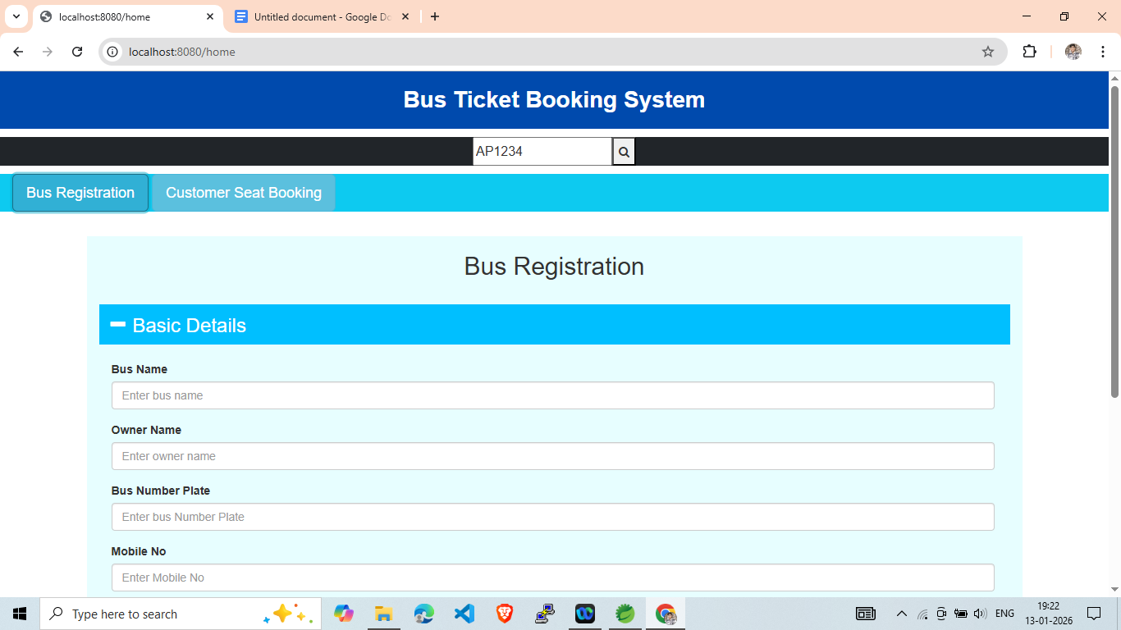

Bus Registration:

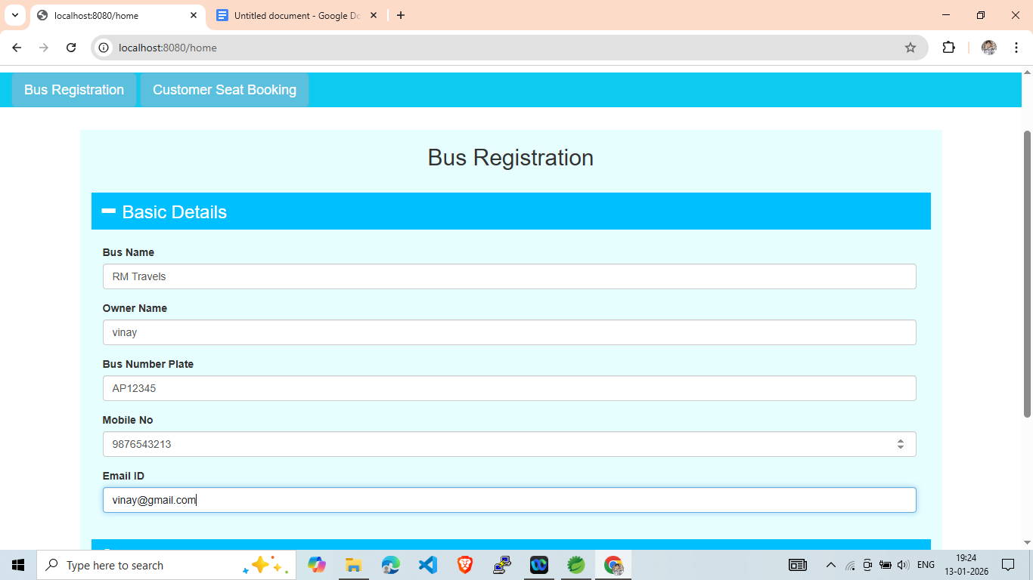

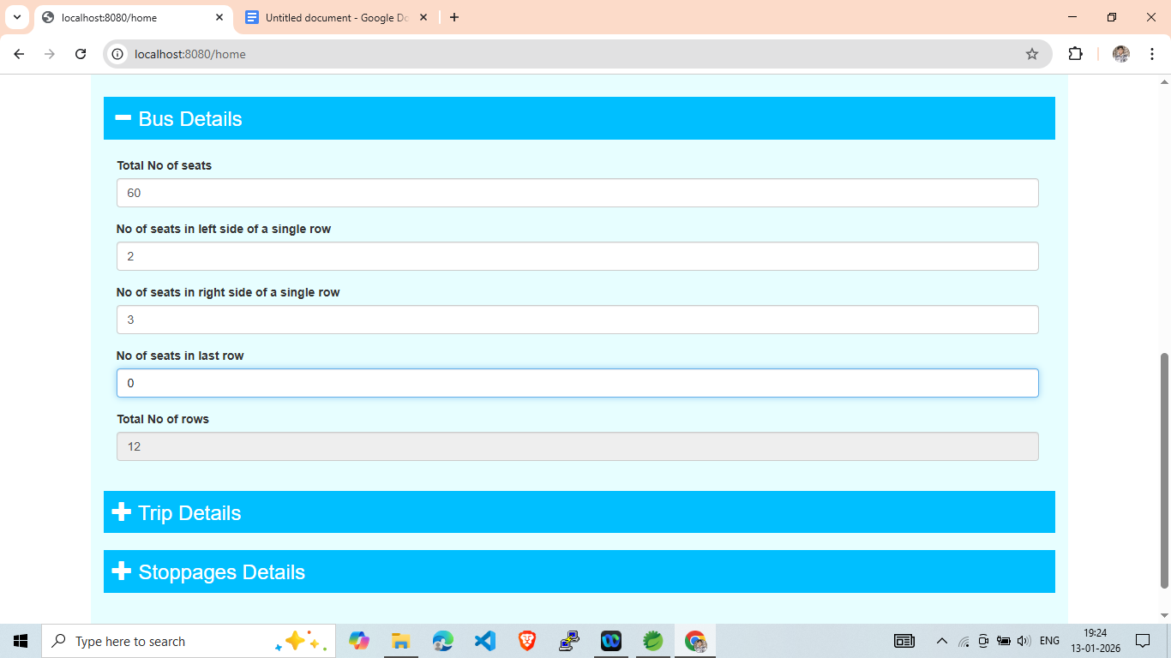

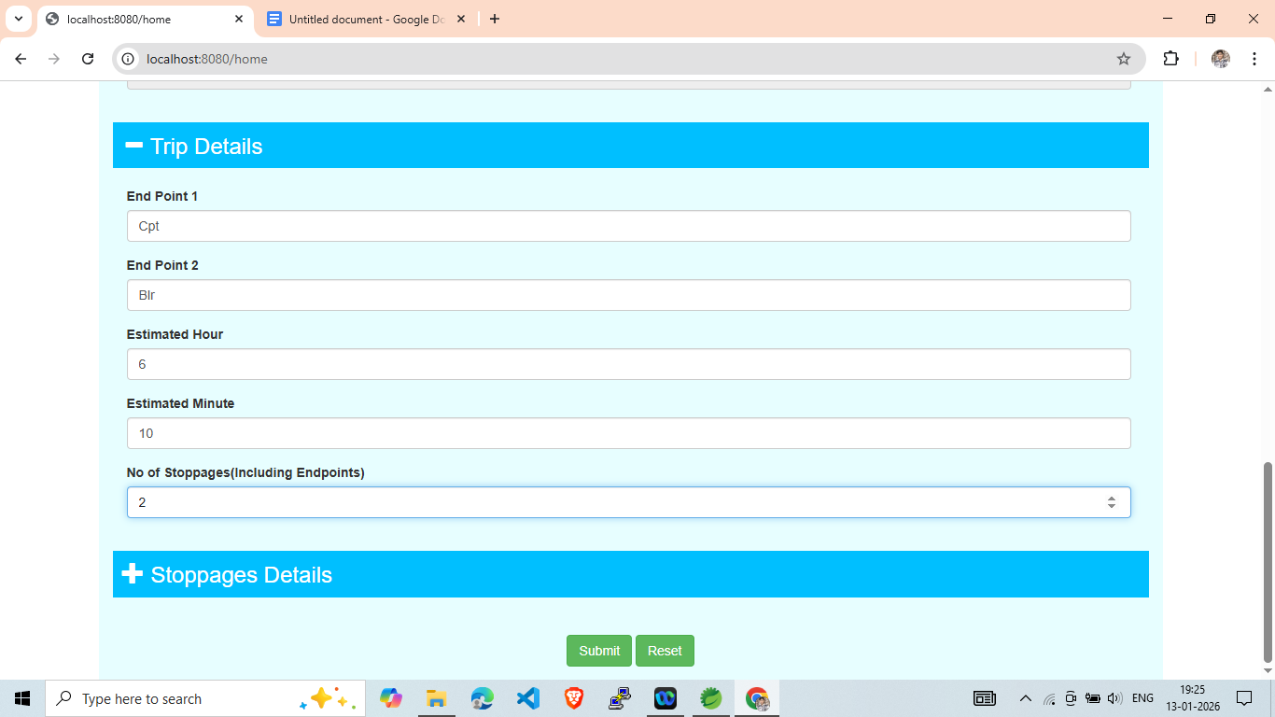

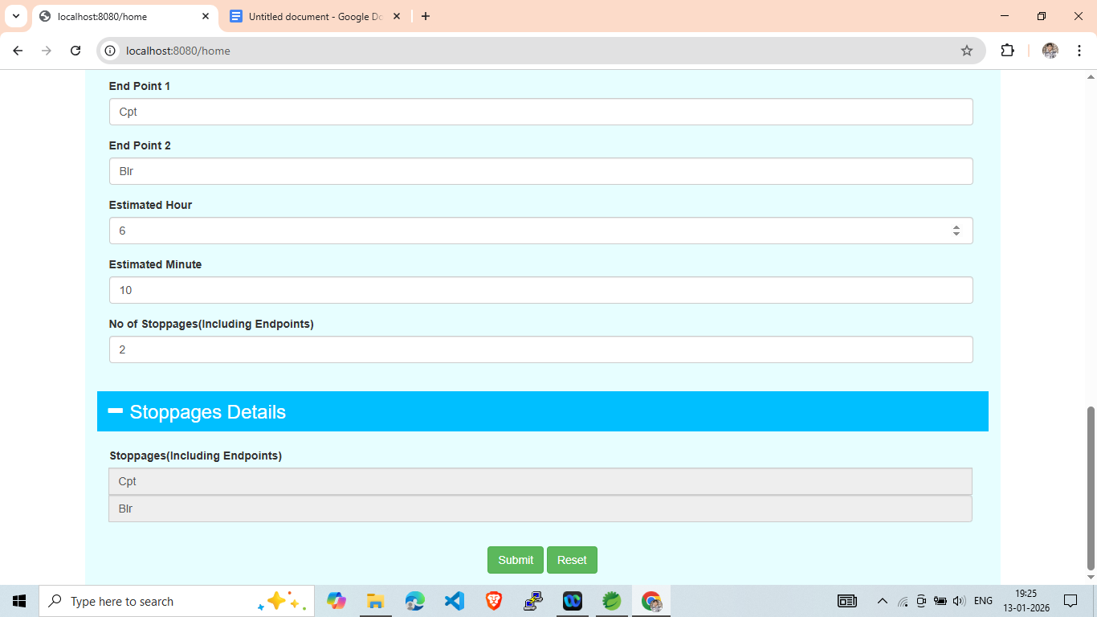

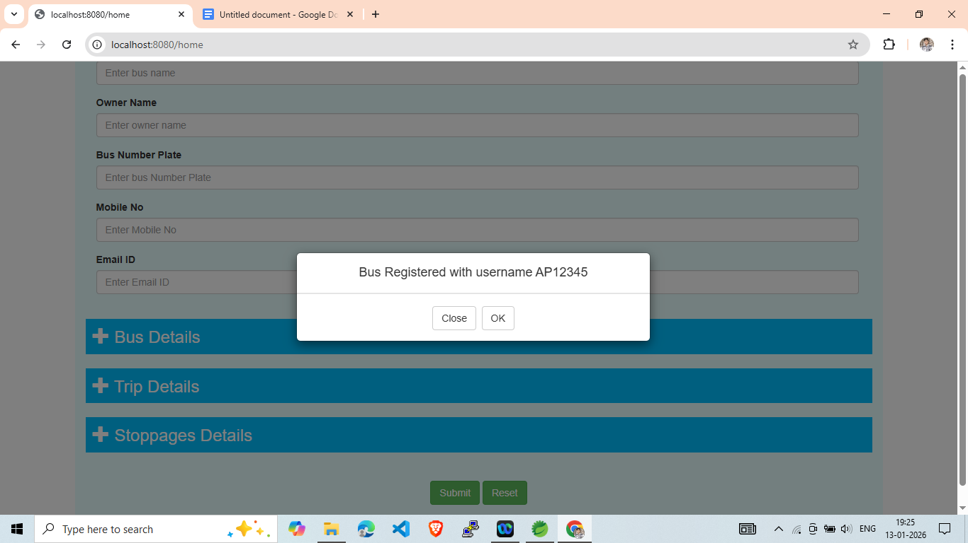

Search Bar :

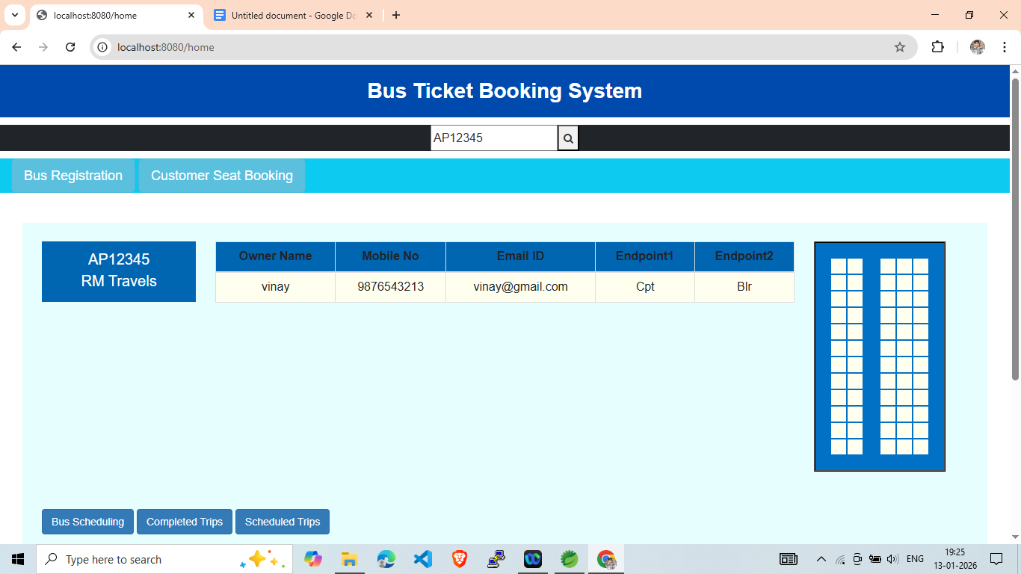

i.Bus Scheduling

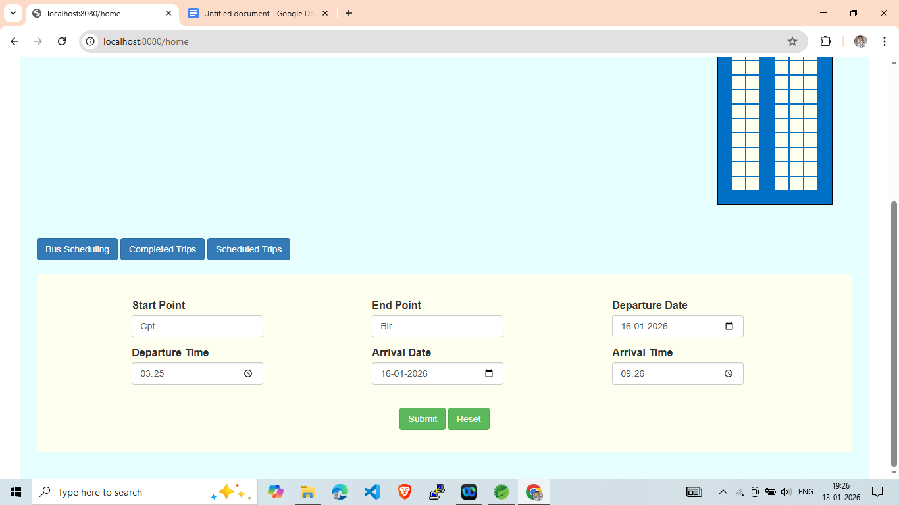

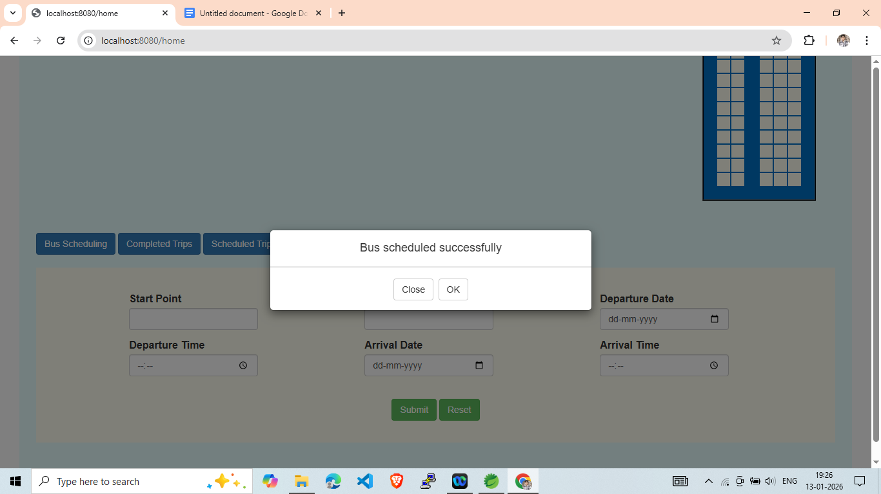

Customer Seat Booking:

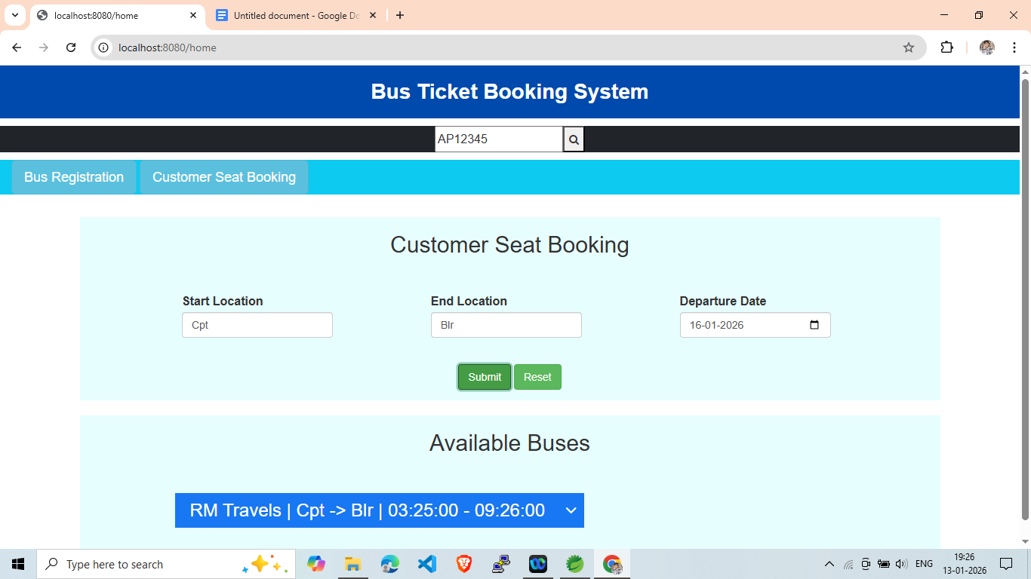

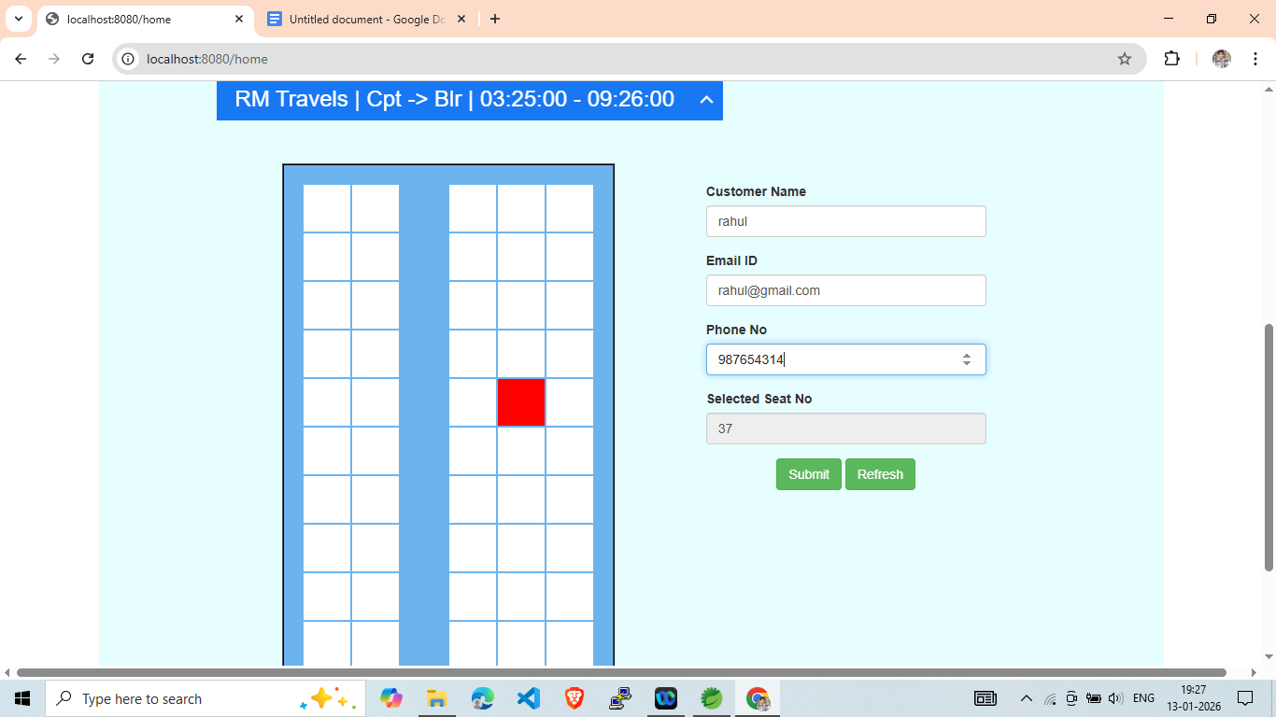

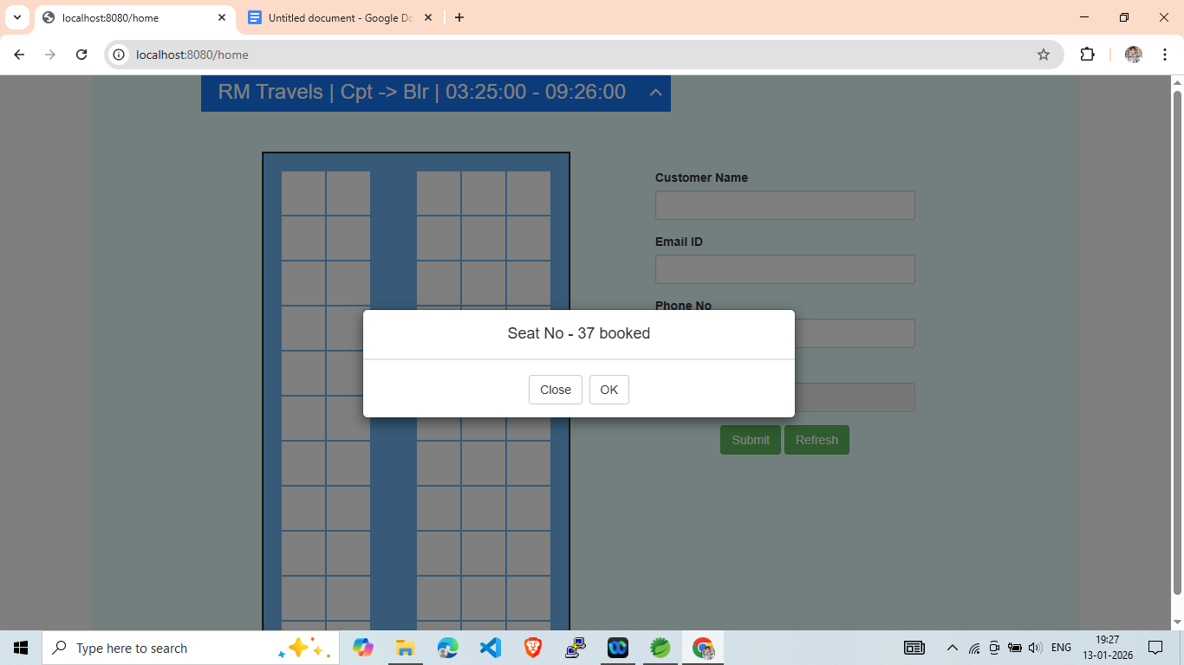

Team Members:

Manoj Kuricheti(2803458)

Shanmukh(2796605)

Tharun(2810016)

